
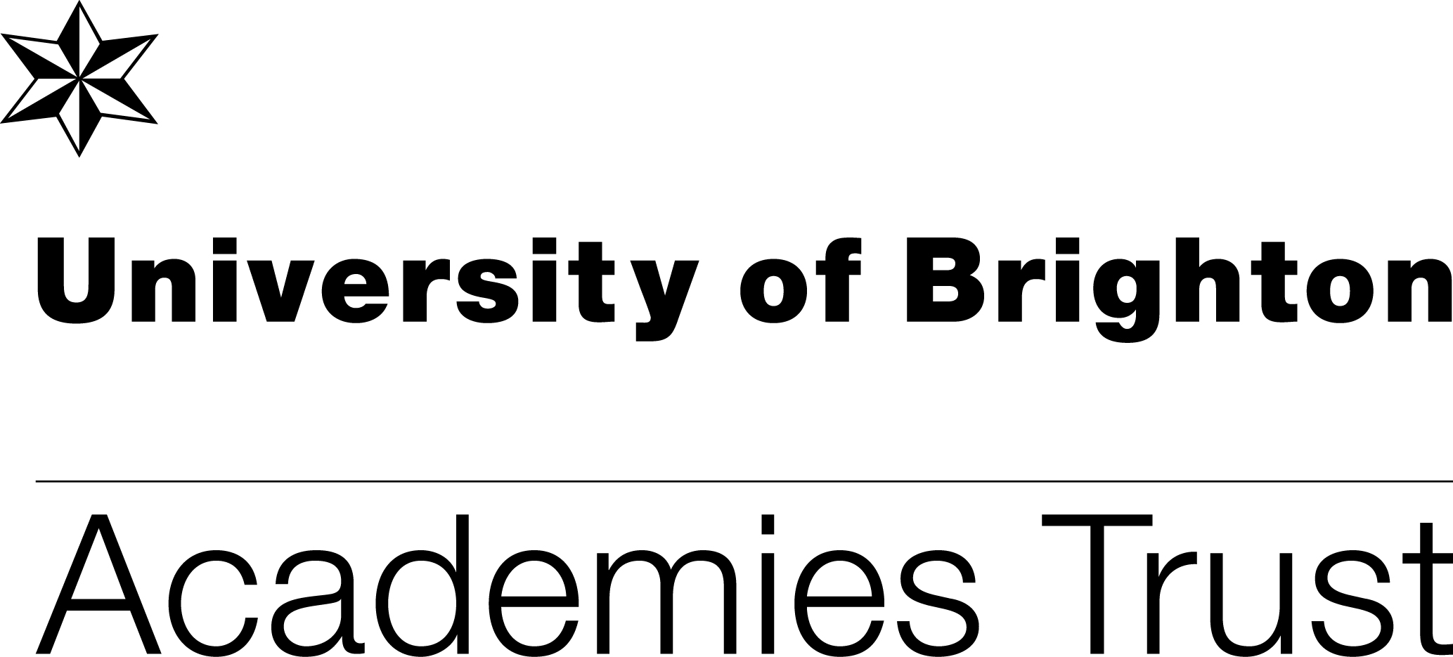
HOLMBUSH PRIMARY ACADEMY
Hawkins Crescent
Shoreham-by-Sea
West Sussex
BN43 6TN
Telephone 01273-592471
Tel/Fax 01273-592660

Email office@holmbushprimaryacademy.org.uk
www.holmbushprimaryacademy.org.uk

Head of Learning: Ms Rebecca Jackson BEd Hons, MA Ed, NPQH

April 2015

Dear Parents/Carers

FRANCE 2015

As you know we are currently in the process of applying for our collective passport. In addition to this your child will need to have a European Health Insurance Card. This is available for all UK residents and entitles the holder to receive free or reduced-cost emergency treatment if necessary. You do not have to pay for this if you apply through the website www.nhs.uk/ehic.

The application is quite straightforward although as the children are under 16 you will have to apply for the card as an adult and then apply for your child as a dependant.

If you have any questions or have any problems with your application please do not hesitate to ask me.

Yours faithfully

Mrs A Hutchinson
Office Manager

